**Risk Management Plan**

**Date: 05/28/2020**

**Project Name**: Board Game Development

**1. Methodology**

The approach we have taken to manage risks for this project includes a process by which the project team is identified and ranked according to the various risks.

**2. Roles and Responsibilities**

* Project Manager – Vineetha Yenugula- Approves or Disapproves the tasks  
  Content Developer –Tejaswi Reddy Kandula
* Bharath Kumar Gandhasiri , Vineetha Yenugula - Researching, writing, gathering, organizing, and editing information regarding project
* Application Developer – Tejaswi Reddy Kandula, Neelesh Saladi - Main role in developing applications
* Marketing Team - Revanth Davuluri
* Game Engineer - Neelesh Saladi, Tejaswi Reddy Kandula, Vineetha Yenugula

**3. Budget and Schedule**

A portion of the original budget estimate, specifically 20% of the budget has been reserved for the sole purpose of mitigating any potential risks. The risk management schedule is still under revision.

**4. Risk Categories**

The identification of potential risks will involve the risk manager, project team and key stakeholders with additional input from the SME. The process will include an evaluation of the project management plan, especially the project scope, schedule, cost and quality.

Furthermore, careful attention will be given to the project deliverables, assumptions, constraints, the WBS, cost estimate and resource plan.

The various methods that could be used for risk identification include:

* Brainstorming
* Interviewing
* SWOT Analysis
* Monte Carlo Analysis

The Brainstorming technique will be particularly suited for this project as it involves an upgrade of pre-existing infrastructure and equipment. A log will be generated and updated as needed and will be stored electronically in the project.

A Risk Breakdown Structure is also created to help facilitate the risk identification and mitigation process.

Some of the broad risk categories are:

* Financial Risk
* Technology Risk
* Process Risks
* Market Risk
* People Risk

**5. Risk Probability and Impact**

For this project, we use a probability/impact matrix to help list the relative probability of the risks occurring along with their corresponding impact. We listed the matrix as per the ranks assigned in the risk register.xls

The matrix shows the risk level:

|  |  |  |  |  |
| --- | --- | --- | --- | --- |
| **Probability** | High |  | Rank 6 | Rank 1  Rank 2 |
| Medium | Rank 3 |  |  |
| Low |  | Rank 4 | Rank 5 |
|  | Low | Medium | High |
|  | **Impact** | | | |

**6. Risk Documentation**

During the course of the project, potential risks will be identified and tracked actively. These risks could fall under any of the aforementioned categories.

As the various project activities are brought to completion, the associated risk factors will be monitored to determine if their corresponding triggers have occurred. These triggers indicate the risk is now a reality. Based on the triggers that have been documented during the risk analysis and mitigation processes, the Risk Manager will have the authority to enact the corresponding mitigation strategies or contingency plans.

Contingency plans, once approved and initiated, will be added to the project work plan and be tracked and reported along with all of the other project activities. Risk management is an ongoing activity that will continue throughout the duration of the project.

As such:

The Risk Manager (PM):

* Review, reevaluate, and modify the probability and impact for each risk item.
* Analyze any new risks that are identified and add these items to the risk list (or risk database).
* Monitor and control risks that have been identified.
* Escalate issues/ problems to management.

The Risk Owner will:

* Help develop the risk response and risk trigger and carry out the execution of the risk response, if a risk event occurs.
* Participate in the review, re-evaluation, and modification of the probability and impact for each risk item on a weekly basis.
* Identify and participate in the analysis of any new risks that occur.
* Escalate issues/problems to PM that,
  + Significantly impact the project’s triple constraint or trigger another risk event to occur.
  + Risk strategy is not effective or productive causing the need to execute the contingency plan.

**Risk Register**

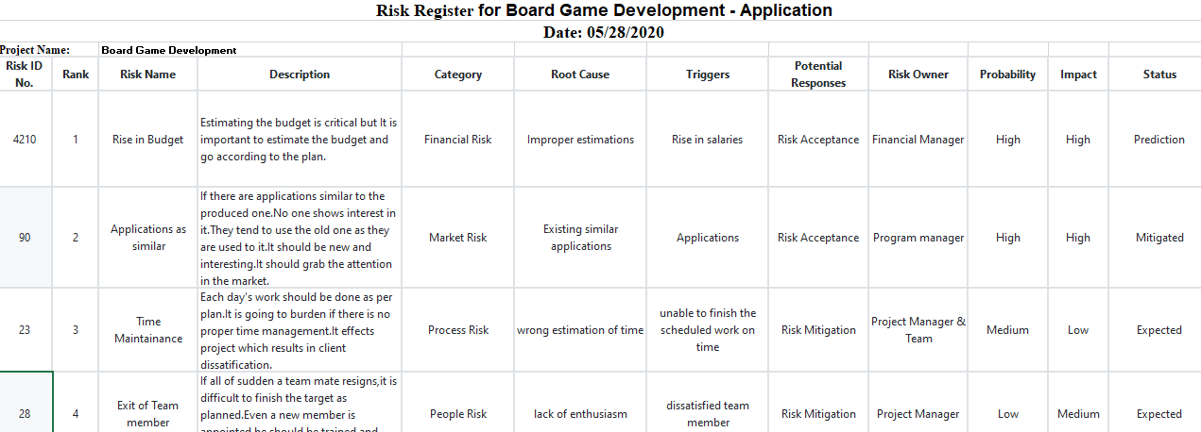

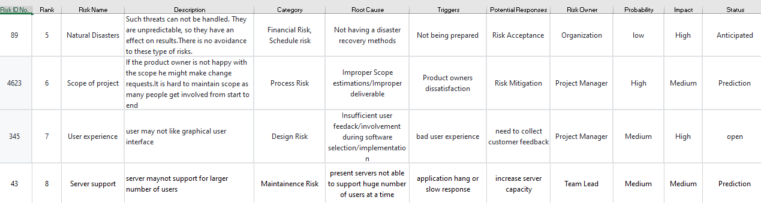

**Risk Mitigation Strategies:**

|  |  |  |  |
| --- | --- | --- | --- |
| **S.No** | **Major Risk** | **Strategies to mitigate Risk** | **Responsible Person** |
| **1.** | Technical Risk | Analyze the pros and cons of the technology with team support and search for the solutions.  Team lead should monitor and control the technology Risk. | Tejaswi Reddy Kandula, Neelesh Saladi, Bharath Kumar Gandhasiri |
| **2.** | People Risk | Find resources with proper skills and abilities, always reach their expectations. | Revanth Davuluri,  Bharath Kumar Gandhasiri |
| **3.** | Financial Risk | Always have 15-20% cash reserves, Monitor cash in and outflows at every stage of project. | Vineetha Yenugula |
| **4.** | Market Risk | Make sure the product or project is simple to use, Much complex design may leads in loss of customer satisfaction. | Revanth Davuluri, |